Species Interactions Crossword Puzzle Activity

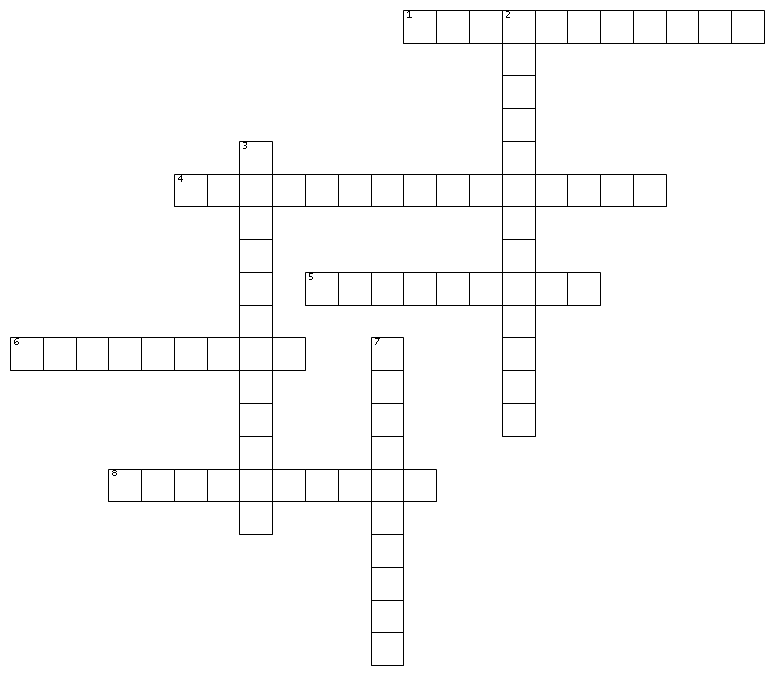
Use the clues to fill in the species interactions crossword below:
ACROSS  1. Two male deer fight over a doe.  4. A cuckoo lays its eggs in a warbler nest. The cuckoo’s young will knock the warbler’s eggs out of a nest and the warbler will raise the cuckoo’s young.  5. On Isle Royale, wolves were reintroduced and hunt moose and beaver, controlling populations of those species.  6. Ants and aphids sometimes live together where the ants protect the aphids from predators and the aphids produce honeydew that the ants feed on.  8. Ticks feed on a deer’s blood. |  | DOWN  2. A wasp lays its eggs on a caterpillar. When the wasp eggs hatch, the larva will eat the caterpillar and kill it.  3. Remora attach themselves to a shark’s body to travel with the shark and feed on the leftover food scraps from the shark’s meals. The relationship neither harms nor benefits the shark.  7. A loblolly pine tree drops its needles, which acidify the soil, indirectly and negatively affecting grass growth around the tree.

