Species Introductions and Interactions Lab

Primer on Invasive Species:
https://www.youtube.com/watch?v=ytHcPVWJ6vY&list=PLd_93a1Y62rB_5lL4tdaFW002GK8-rAWL&index=10&t=249s

ECOLOGICAL BACKGROUND
Species interactions describe the relationships among different species living in the same location. As we discussed in lecture, species can have many types of interactions, ranging from mutualisms and commensalism to competition and parasitism. Interactions can occur between species that are native to an area, as well as between native species and species that are introduced into an area. The relocation of these “introduced” organisms across geographical boundaries mostly occurs directly or indirectly by humans, and has been increasing over time as human forms of transportation have improved. In some cases, humans have intentionally dispersed species, such as some reptiles and arthropods that were imported through the pet trade or plants that were transported from Europe to North America for agricultural and ornamental purposes. Other species are transported accidentally by planes, trains, and automobiles, as well as cargo and cargo ships, horticultural and ornamental plants, and wood products.

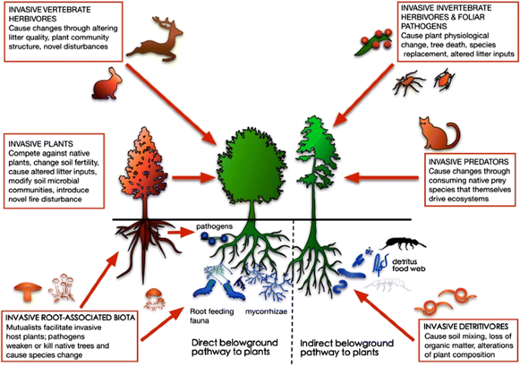
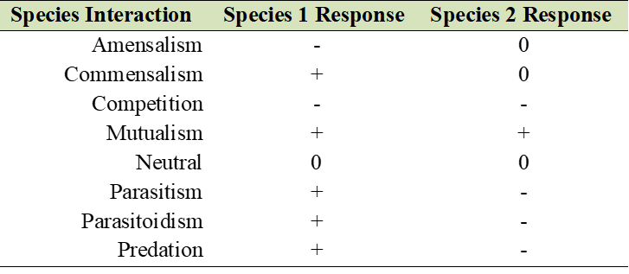
Many of these introduced species are not able to survive in the new ecosystem. Others may find their new environment optimal for establishing, growing, reproducing, adapting, and dispersing to create new populations. Some of these species that adapt well increase their populations rapidly, and potentially have negative impacts on native species, disturbance and ecosystem cycles (e.g., nitrogen or carbon cycle), or the economy. These so-called “invasive species” can alter the ecology and evolution of native species, ecology of ecosystems, and can be important drivers of species extinction.
Table 1. Types of interactions between species.
Figure 1. Examples of impacts of introduced, invasive species on the aboveground and belowground environment. Figure from Wardle and Peltzer (2017); https://doi.org/10.1007/s10530-017-1372-x.

In this lab, you will examine data and relationships among organisms to assess species interactions and the ecological consequences of introduced species. Specifically, you will engage in hypothesis testing and data analysis, think about and develop a complex food web, and research an introduced species on your own to increase your understanding of the complexities surrounding species introductions and interactions.
PART 1: Impacts of Invasive Species on Native/Endangered Species

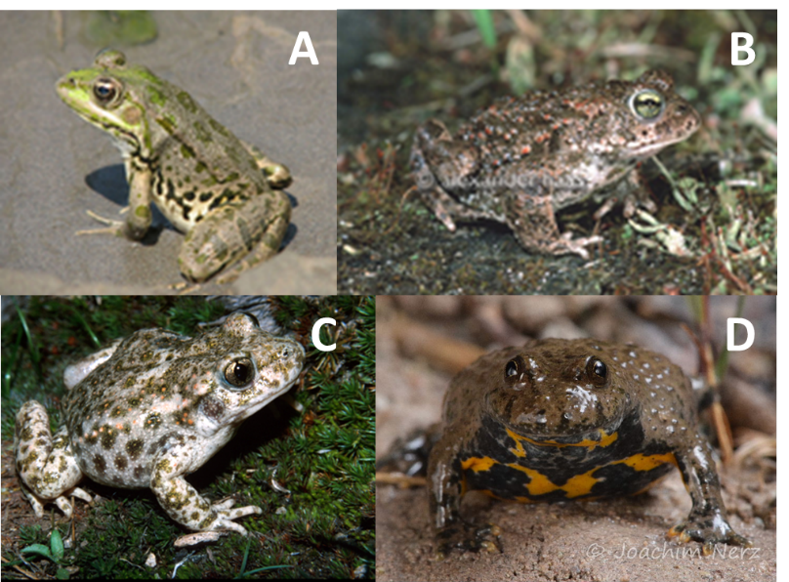
Global change causes community composition to change considerably through time, with new combinations of interacting species. To study the consequences of newly established species interactions between range expanding or introduced species and native species, one available source of data could be observational surveys from biodiversity monitoring. This section uses data from a Swiss amphibian monitoring program to assess the impacts of expanding water frog populations (includes phenotypically similar Pelophylax ridibundus, P. lessonae, and P. esculentus) on population sizes of native natterjack toads (Epidalea calamita), common midwife toads (Alytes obstetricans), and yellow-bellied toads (Bombina variegata), which are endangered in peripheral parts of their range like northern Switzerland. Studies on population impacts of dominant species on population sizes of endangered species using data from biodiversity monitoring programs can help inform conservation policy and to decide whether competing species should be subject to population management. Use the accompanying dataset to answer the following questions and assess the impacts of the water frogs on the native toad population.
Figure 2. Images of the (A) water frog, Pelophylax ridibundus, image by Omid Mozaffari, (B) natterjack toad, Epidalea calamita, image by Alexander Haas, (C) common midwife toad, Alytes obstetricans, image by Iñigo Martínez-Solano, and (D) yellow-bellied toad, Bombina variegata, image by Dr. Joachim Nerz.

Q1) Before we dig into the analysis of the frog effects on toads, let’s look at the environment in which the frogs and toads live. Specifically, let’s see if species counts vary based on elevation (meters above sea level). Make some figures to assess the range of elevations for each species. Include the figures below (remember to include axes titles and a figure description). Note: some species may have a lot of zeroes, so you may have to make a copy of your data and organize and clean up your data to remove the unnecessary zeroes for this portion. Do not delete your zeroes completely because they will be helpful for the next part.

Q2) Did you find any variation in the range of elevations for the species?

Q3) Think about your results from Q1 and Q2. Review the accompanying dataset, including the “Metadata” and “Lab 3 Data” tabs, and write three hypotheses detailing how you think the water frogs might be affecting 1) natterjack toads, 2) common midwife toads, and 3) yellow-bellied toads.

Natterjack toads:

Common midwife toads:

Yellow-bellied toads:

Q4) There are a couple different ways to analyze the data in the accompanying dataset. For example, we can use the water frog count data as is or transform it to a presence/absence variable where 0 = no water frogs and 1 = presence of water frogs and then look at the mean (average) number of toads when there are no frogs versus when there are frogs. Let’s use this second option to develop a figure and test your hypothesis. Be sure to calculate and include standard error bars on your figure (see “Metadata” tab for standard error calculation). Include your figure below.

Q5) For your figure and analysis from Question 4, what are your independent and dependent variables? Are they numerical or categorical? If numerical, are they discrete or continuous? If categorical, are they ordinal, nominal, or binary?

Q6) What are the effects of the water frog populations on the native toad community? How did the toad counts vary based on frog presence and absence? Were your hypotheses supported or not supported by your data analysis? Note: this is a very simplified analysis as there are a lot of other factors that we would ordinarily include to model the effects of water frogs on native toad communities, but that is for a more advanced class…

Q7) Based on your results, would you recommend that the water frog populations be managed to reduce impacts on the native toad community?

References
Roth, T., Bühler, C., Amhein, V. 2015. Data from: Estimating effects of species interactions on populations of endangered species, Dryad, Dataset, https://doi.org/10.5061/dryad.7gt4m
Roth, T., Bühler, C., and Amrhein, V. 2016. Estimating effects of species interactions on populations of endangered species. The American Naturalist, 187(4), pp.457-467. https://doi.org/10.1086/685095
Schmidt, B.R. 2005. Monitoring the distribution of pond-breeding amphibians, when species are detected imperfectly. Aquatic Conservation: Marine and Freshwater Ecosystems 15:681-692.
Tanadini, L.G. and Schmidt, B.R. 2011. Population size influences amphibian detection probability: implications for biodiversity monitoring programs. PLOS ONE 6:e28244.
PART 2: Impacts of Invasive Species on Food Webs

Oak species (Quercus spp.) produce large autumnal acorn crops every two to five years, and produce few or no acorns during intervening years. Acorns are a critical food source for white-footed mice (Peromyscus leucopus) and eastern chipmunks (Tamias striatus). Mice are important predators of the pupal stage of the spongy moth (Lymantria dispar dispar). This introduced insect periodically undergoes outbreaks that defoliate millions of acres of oak forests, decreasing tree growth, survival, and acorn crop production. An abundance of acorns also provides food for white-tailed deer (Odocoileus virginianus). Mice, chipmunks, and deer are hosts of the black-legged tick (Ixodes scapularis), which carries Lyme disease. Based on this excerpt, make a drawing or sketch of the interactions between spongy moths, acorns, mice, chipmunks, deer, deer ticks, and Lyme disease. Think about which species are primary producers versus primary, secondary, tertiary, etc. consumers. Be sure to list the interaction between the species. You can either print this page and draw it out or draw it out digitally in PowerPoint. Be as creative as you like. Below the food web, summarize how you think spongy moth ultimately affects Lyme disease prevalence in the ecosystem.

PART 3: Impacts of Invasive Species Abound
For this third section, in honor of it being National Invasive Species Awareness Week, you will conduct some research on an introduced species. EDDMapS (https://www.eddmaps.org/) is a web-based mapping system for documenting invasive species and pest distributions. It contains a database of many introduced species in North America that you can search from. The National Invasive Species Information Center (https://www.invasivespeciesinfo.gov/) also has a lot of good information about invasive species and has some species profiles to explore. Pick a plant, disease, reptile, amphibian, fish, mammal, arthropod, bird, mollusk, or annelid and then fill in the information for the introduced organism below.

Q1) What is the common name of your selected organism?

Q2) What is the scientific name (Genus species) of your selected organism?

Q3) Where is the organism from (i.e., what is its native range? e.g., Europe, Asia, Australia)?

Q4) In which states/regions can the organism be found in North America (i.e., what is its introduced range; Hint: EDDMapS is a good source for this)?

Q5) What impacts (positive or negative) has the organism had on the introduced environment?

Q6) What interactions does the organism have with other species in North America? For example, maybe it competes with a native plant/animal or has a mutualistic relationship with another introduced species. Be as detailed as possible and indicate what type of interaction is occurring between the introduced species and any impacted native or other introduced species (refer to Figure 1 for a list of interactions).

Q7) Has there been any effort made to control this species? If so, how?

Q8) What resource(s) did you use to find this information?

