Species Introductions and Interactions Lab FAQs

How do I make a scatterplot in Excel to look at the toad and frog distribution by elevation?
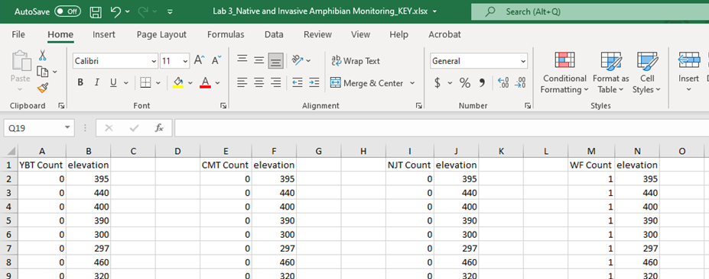
- Step 1: Determine which variables you want in your figure and whether they are the dependent (y-axis) or independent (x-axis) variables. In this case, we want to look at toad/frog count by elevation. My suggestion would be to duplicate and section your data in a new tab where you have each toad/frog count and the corresponding elevation separated out from the other frog/toad counts and corresponding elevation data. Be sure to leave a space between each set of columns so you can sort your data without affecting the other columns of data. You can also put the columns on separate tabs if you would like.

- Step 2: After you have your data partitioned, you will notice that there are a lot of zeroes for the toad/frog species. We don’t need all of those zeroes for this scatterplot (it will just create a solid blue line of dots at the bottom of the figure), so we can remove the rows that have a zero count along with its corresponding elevation. To do this, we are going to sort our data by smallest to largest by highlighting our toad/frog count column (hover over the column heading “A” and click down to highlight) and then clicking on the “Sort & Filter” button -> “Sort smallest to largest” on the right side of the screen. Make sure you “expand the selection” so you are sorting the elevations to correspond with the toad counts. Sorting it smallest to largest will move all the counts with zeroes up to the top, so we can get rid of them all at once.
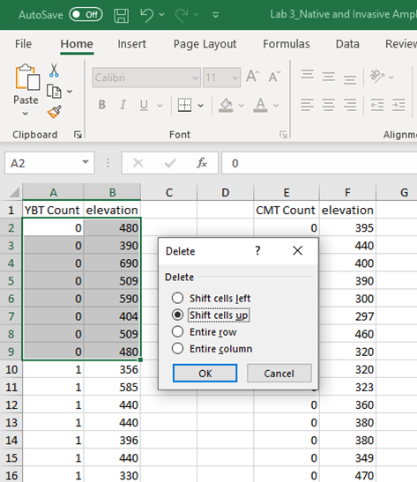
- Step 3: Once you have all of your counts with zero at the top, you can highlight the zeroes and the corresponding elevations by just left clicking and dragging over the cells. Stop highlighting when you get to the toad/frog count of 1. When you have both columns of cells highlighted, right click on the data and click “Delete” which is between “Insert” and “Clear Contents.” This will bring up a box like the image to the left. Here, you will check the “Shift cells up” box and click “OK.” This will get rid of the rows with zeroes. If you have your toad/frog data in separate tabs, you can just highlight the numbers to the left and delete the entire row without having to worry about deleting the data in the other columns. Do this step for each set of toad/frog count columns.
- Step 4: Once you have your zero-count data removed, you can navigate to the top of the Excel spreadsheet, between the “Home” and “Page Layout” tabs where you will see the “Insert” tab. Click on the “Insert” tab then click the scatterplot box under the “Charts” section and click on the first option (scatterplot without lines).
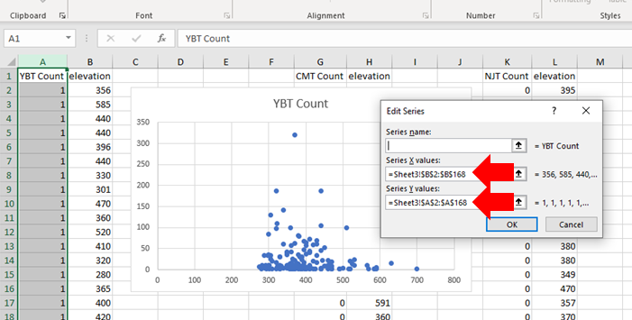
- Step 5: This will open a white box on your screen. Right click on the white box and click the “Select data” icon. This will open an empty “Select Data Source” box for you to select which data you will add to the figure. In the open “Select Data Source” box, click the “Add” button under Legend Entries. This will bring up an “Edit Series” box for you to identify the data points you want included in the figure.
- Step 6: You do not need to enter anything for the “series name.” The first box to click on would be the “Series X values” box that will include all of the “elevation” values, which is our independent variable in this case. Once you click on the “Series X values” box, highlight all of the elevation values in column B. Next, click on the “Series Y values” box and delete the “={1}” information in the box. After you delete that, you can highlight all of the YBT Count values in column A. Once all of the data points are highlighted, click the “OK” button at the bottom of the box. Check that you do not get an error and that your figure looks like it has a good distribution of data points (i.e., not just one), then click the “OK” button at the bottom of the “Select Data Source” box.
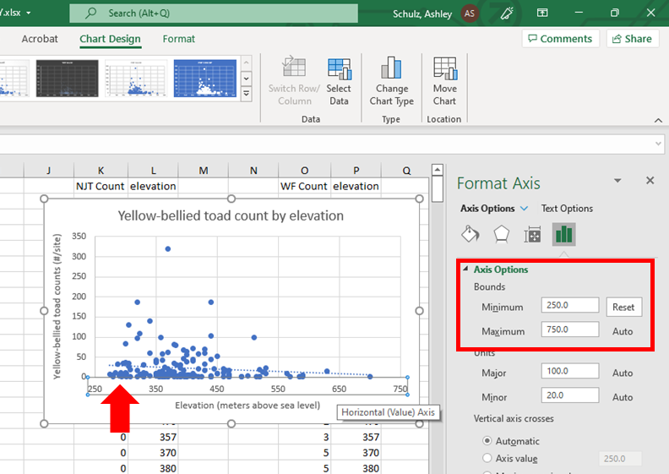
- Step 7: If you notice that all of your data are clustered in the middle of the graph with none on either end of the figure, you can modify your bounds for your x-axis by double clicking on the x-axis and opening the “Format axis” box on the right side of the screen. Change your minimum bound to 250 and your maximum to 750 (it should automatically change when you change the minimum to 250). This will zoom in and help you see your data points a little clearer.
- Step 8: Next, click on your new figure and navigate to the “Chart Design” tab and “Add Chart Elements” button at the top of the spreadsheet *OR* click on the little green plus sign on the right side of your figure where it says “Add Chart Elements.” From there, go down the menus to the “Axis Titles” and add your horizontal and vertical axis titles. Be sure to name them based on the values on your x- and y-axis, respectively. To add a trendline, do the same thing, but go to the “Trendline” button on the menu and click the “Linear” trendline option.
- Step 9: To add your linear equation, you can double click on your trendline in your figure and open a side panel to “Format Trendline.” Scroll to the bottom and check the “Display Equation on chart” and “Display R-squared value on chart” buttons. An equation and R-squared value should appear on your graph, and you would just move it to a place where it’s not hiding the data points.
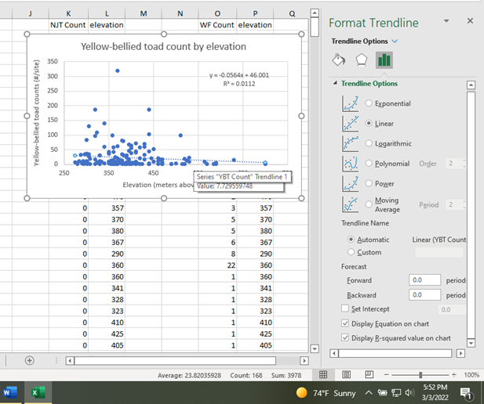
- Step 10: And there you have it! Your figure has the basic elements it needs. You can add a title up top or figure description in the word document. Feel free to tinker with the colors if you would like. When you are happy with your figure, copy and paste it into your lab word document under the corresponding question asking for a scatterplot. Good work! Now, repeat for the other three toad/frog species.
How do I make a bar graph in Excel to look at the effects of water frog presence and absence on toad counts for the three toad species?
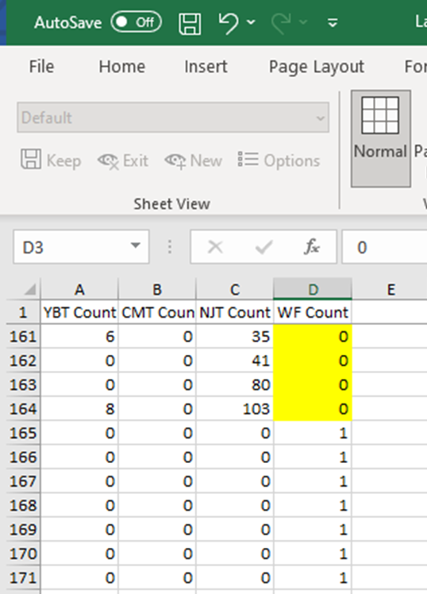
- Step 1: For this part, I would again recommend creating a new tab with your original data copied and pasted over. For this data analysis, we want the zeroes in there, so be sure you take the data from the original dataset, not the modified data from the elevation figures. We only need the YBT count, CMT count, NJT count, and WF count columns.
Break between water frog presence (1 frog +) and absence (0 frogs)
- Step 2: Once you have those four columns in a new tab, we are going to go to our “Sort & Filter” button to sort our WF count column by “Smallest to Largest.” Again, make sure you “expand the selection,” so you have the correct toad counts with each WF count in the dataset.
- Step 3: Since we are changing a numerical variable (count of water frogs) to categorical (presence/absence of water frogs), we are going to set up a table in the Excel spreadsheet to put our numbers into. Here, we can look at our data two ways, we can look at total abundance of each toad species when water frogs are present versus when they are absent OR we can look at the mean (average) abundance of toad species when water frogs are present versus when they are absent. Here, I’ll show you how to calculate the mean number of toads when water frogs are present versus when they are absent, but you could just look at total abundance if you want to. Below, are the tables you will set up to get your mean (AVERAGE) numbers, standard deviation (STDEV), and standard error (standard deviation divided by square root of the sample size) for each toad species. Note the range of values for the mean and standard deviation equations. That’s where the break should occur between the absence of frogs (i.e., zero frogs) and presence of frogs (i.e., at least one frog in the water frog count). Double check that your data are at the same break.

 | G | H | I | J
1 | Water Frogs? | Yellow-Bellied Toad | Common Midwife Toad | Natterjack Toad
2 | Absent | =AVERAGE(A2:A164) | =AVERAGE(B2:B164) | =AVERAGE(C2:C164)
3 | Present | =AVERAGE(A165:A482) | =AVERAGE(B165:B482) | =AVERAGE(C165:C482)
4
5 | Water Frogs? | YBT Standard Deviation | CMT Standard Deviation | NJT Standard Deviation
6 | Absent | =STDEV(A2:A164) | =STDEV(B2:B164) | =STDEV(C2:C164)
7 | Present | =STDEV(A165:A482) | =STDEV(B165:B482) | =STDEV(C165:C482)
8
9 | Water Frogs? | YBT Standard Error | CMT Standard Error | NJT Standard Error
10 | Absent | =H6/sqrt(163) | =I6/sqrt(163) | =J6/sqrt(163)
11 | Present | =H7/sqrt(318) | =I7/sqrt(318) | =J7/sqrt(318)

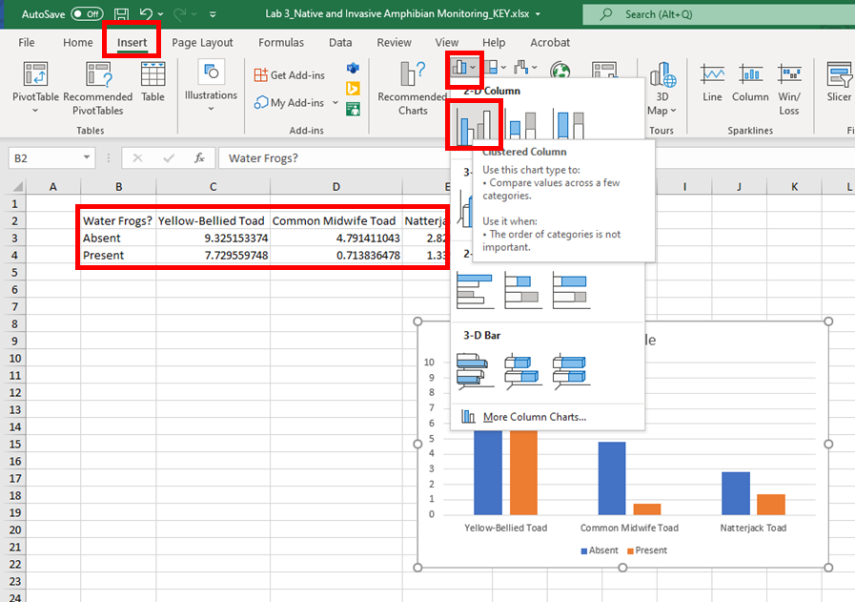
- Step 4: Once you have your table set up and your equations are correctly picking up the numbers in the original four columns with the toad and frog counts, you can highlight your top table with mean number of toads and click the “Insert” tab at the top of the page, then select the top left “Bar chart” box and pick the “2-D Clustered Column” figure. This will add your figure to your spreadsheet. Be sure to add your axes titles. Your x-axis will be “Toad species” and your y-axis will be “Mean toad count (± SE)” (unless you go with the Total toad abundance calculation used in class where we use the SUM function instead of the AVERAGE function). To get the ± (plus or minus) symbol, you can go to the “Insert” tab and at the far right, you will see the “Symbol” button. You can click on that and find the symbol in there or you can copy the text above and copy it into your axis title box by simultaneously clicking the “Ctrl” + “V” buttons on your keyboard to paste.
Note: I copied and pasted the values into a new, clean sheet to show you these steps, so the associated columns changed (in case you were wondering…)
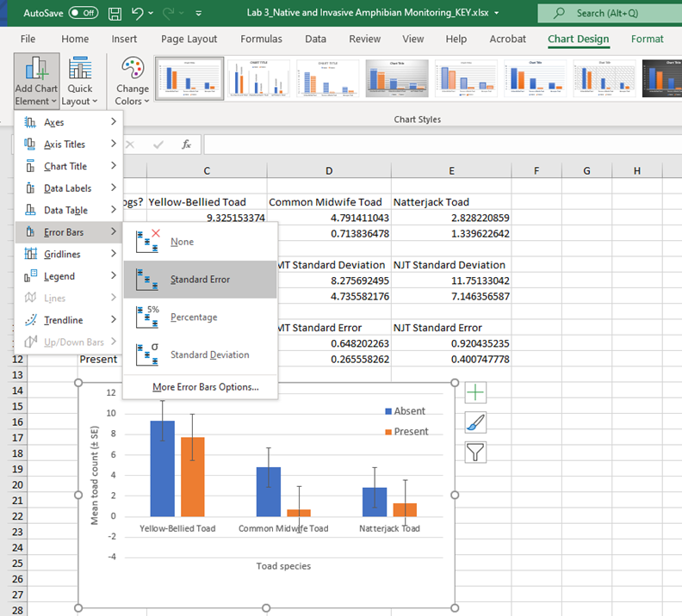
- Step 5: Once you have your basic figure, you can add your standard error bars using the data from your bottom table (the standard deviation table was just used to calculate standard error here). To add the initial bars, click on your figure and then navigate to the green plus sign next to the figure or the “Chart design” button at the top of the screen then the “Add chart element” box. Click on the “Error bars” box and then the “Standard error” box. This will add default setting error bars, which we will customize based on the standard error calculations we just made.

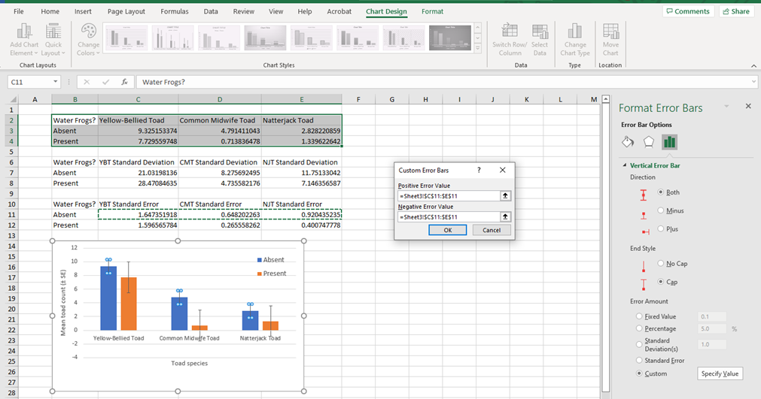
- Step 6: To customize the error bars, you will first double click on the error bars for the blue bars. This will open a side “Format error bars” tab where you can click the “Custom” and “Specify value” buttons under the “Error Amount” section. A new box will open up and ask for the positive and negative error values. Clear out the “={1}” code in each box and highlight the standard error values in the corresponding cells (see red arrow above). Copy the same cells for the positive and negative error values, then click “OK.” The error bars for the blue (absent) bars should adjust accordingly. Repeat this step for the standard error bars on the orange (present) bars using the “Present” standard error values in the row below for the positive and negative error values (purple arrow), which correspond to the averages calculated for the toads when frogs are present. After you adjust your other bars, your y-axis scale should adjust back to the normal 0-12 range without the negative values.
- Step 7: And there you have it! Your figure has the basic elements it needs. You can add a title up top or figure description in the word document. Feel free to tinker with the colors if you would like. When you are happy with your figure, copy and paste it into your lab word document under the corresponding question asking for a scatterplot. Good work! You only need this one figure with the three toad species on it to make interpretations about the effects of water frog absence and presence on mean toad count for each of the three species.

